

User Requirements Specifications



ICT & Software Engineering - Semester 2

Class: S2-CB-01

Group: 4

Tutor: Chung Kuah

Location: Fontys ICT, R10 building, Eindhoven

Group „BulCari“ members:

Stoycho Stoychev – 4292723

Tony Jiang – 4172507

Stela Trencheva – 4095200   
 Veronika Valeva – 4090349

Date: February/March 2021

Table of Contents

Agreements with client 2

Fontional Requirements 2

Use cases 2

**Use case:** Log in. 2

**Use case:** Add employee. 3

**Use case**: Remove employee. 3

**Use case:** Assign employees to shifts 3

**Use case:** Remove employees from shifts 4

**Use case:** View shifts and assigned employees 4

**Use case:** Approve stock request 4

**Use case:** Reject stock request 5

**Use case:** View stock statistics. 5

**Use case:** Product search. 5

**Use case:** View employee statistics. 5

**Use case:** Employee search. 6

**Use case:** Log out. 6

Gui 7

Website wireframe 11

# Agreements with client

* Agreed on a meeting in week 6.
* Prefer color for the application is light blue color.
* The HR administration should be able to add employees, renew employees’ contract, assign shift to employees and remove employees.
* Keep contract history of employees.
* Contract information: full time contract, 80% contract and flex contract.
* Full time contract: 48 hours a week/ 6 days a week.
* 80% contract: 32 hours a week/ 4 days a week.
* Flex contract: on call when store need more workers.
* First time contract is a one-year contract.
* Renew contract 3 times for three years after that contract with no end date.
* Management should be able to see statistics about the individual employee and stock.
* Send restock request.
* Last depot workers should be able to see data about stock and incoming shelf restock requests.

# Fontional Requirements

**FR-01: the application should let you choose which user you want to log in too.**

Each user can see certain stuff and can do some stuff in the application.

**FR-02: HR administration should be able to add employee in the application.**

**FR-03: HR administration should be able to remove employee in the application.**

**FR-04: HR administration should be able to assign shift to employee in the application.**

**FR-05: Management should be able to see individual employee statistic.**

**FR-06 Management should be able to see individual stock statistic.**

**FR-07: Depot worker should be able to see restock request in the application.**

**FR-08: Depot worker should be able to approve restock request.**

**FR-09: Depot worker should be able to reject restock request.**

# Use cases

### **Use case:** Log in.

**Actor:** HR administration/ Management/ Depot-worker.

**Main Success Scenario:**

1. Open the application and choose a job position.
2. Enter a username and password.
3. The “login” button is pressed, and the user logs in into the profile.

### **Use case:** Add employee.

**Actor:** HR administration.

**Main Success Scenario:**

1. HR administration input employee information and confirms.
2. Application saves the information and display it on a screen.

**Extensions:**

1a: Some employee information is not filled in.

1. Application displays a message to fill the missing requirement information.
2. Returns to MSS step 1.

### **Use case**: Remove employee.

**Actor:** HR administration.

**Main Success Scenario:**

1. HR administration select an employee and confirms remove.
2. Application removes the information and remove it on the display screen.

### **Use case:** Assign employees to shifts

**Actor:** Administrator

**Main Success Scenario:**

1. Administrator clicks “Assign Shifts” tab page.
2. Administrator chooses “Day” and “Shift type”.
3. System shows assigned employees and available employees.
4. Administrator selects one of the available employees and clicks “Assign”.
5. System adds selected employee to assigned employees, removes it from available employees for this Day/Shift type and shows confirming message.

**Extensions:**

5a: No employee is selected in neither available employees list nor assigned employees list.

1. System shows warning message.
2. Return to MSS step 4.

### **Use case:** Remove employees from shifts

**Actor:** Administrator

**Main Success Scenario:**

1. Administrator clicks “Assign Shifts” tab page.
2. Administrator chooses “Day” and “Shift type”.
3. System shows assigned employees and available employees.
4. Administrator selects one of the assigned employees and clicks “Remove”.
5. System removes selected employee from assigned employees, adds it to available employees for this Day/Shift type and shows confirming message.

**Extensions:**

5a: No employee is selected in neither available employees list nor assigned employees list.

1. System shows warning message.
2. Return to MSS step 4.

### **Use case:** View shifts and assigned employees

**Actor:** Administrator

**Main Success Scenario:**

1. Administrator clicks “View Shifts” tab page.
2. System displays a table with days of the week, shifts and assigned employees.

### **Use case:** Approve stock request

**Actor:** Depot-worker

**Main Success Scenario:**

1. System displays incoming restock requests.
2. Depot-worker clicks on a request.
3. System displays info about the requested stock.
4. Depot-worker clicks “Approve”.
5. System removes request from incoming requests, adds it to “approved requests” tab page and shows appropriate message.

**Extensions:**

5a: There is no availability of the requested stock in the warehouse.

1. System shows warning message, automatically rejects the request and adds it to “rejected requests” tab page.
2. End of use case

### **Use case:** Reject stock request

**Actor:** Depot-worker

**Main Success Scenario:**

1. System displays incoming restock requests.
2. Depot-worker clicks on a request.
3. System displays info about the requested stock.
4. Depot-worker clicks “Reject”.
5. System removes request from incoming requests, adds it to ”rejected requests” tab page and shows appropriate message.

### **Use case:** View stock statistics.

**Actor:** Management

**Main Success Scenario:**

1. The management clicks on button “Stock statistics”.
2. The management chooses the tab “Statistics”.
3. The application displays statistics about all products (name, quantity, serial number)

### **Use case:** Product search.

**Actor:** Management

**Main Success Scenario:**

1. The management clicks on the button “Stock statistics”.
2. The management chooses the tab “Search”.
3. The management inputs the serial number of the wanted product into the text box.
4. The application displays information about the product found.

### **Use case:** View employee statistics.

**Actor:** Management

**Main Success Scenario:**

1. The management clicks on the button “Employee statistics”.
2. The Managements chooses the tab “Statistics”.
3. The application displays statistic for the employees.

### Use case: Employee search.

**Actor:** Management

**Main Success Scenario:**

1. The management clicks on the button “Employee statistics”.
2. The management chooses the tab “Search”.
3. The management enters the ID number of the wanted employee.
4. The application displays the information about the found employee.

### Use case: Log out.

**Actor:** HR administration/Management/Depot-worker

**Main Success scenario:**

1. The user clicks the button “Log Out”.
2. The application logs out the user and displays the log in page.

# Gui

Depot worker’s profile when logged in.

Management’s profile when logged in.

HR administration/ admin’s profile when logged in.

Login function. Each user has to login through the application.

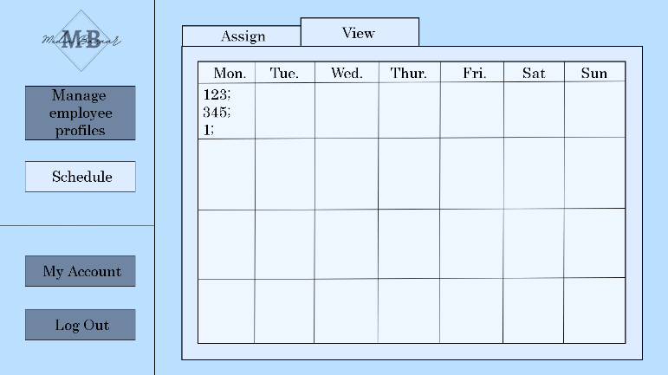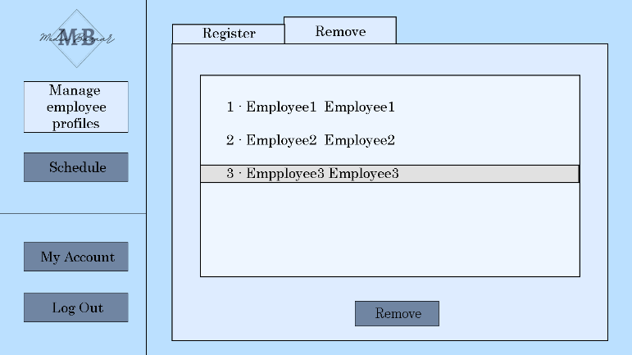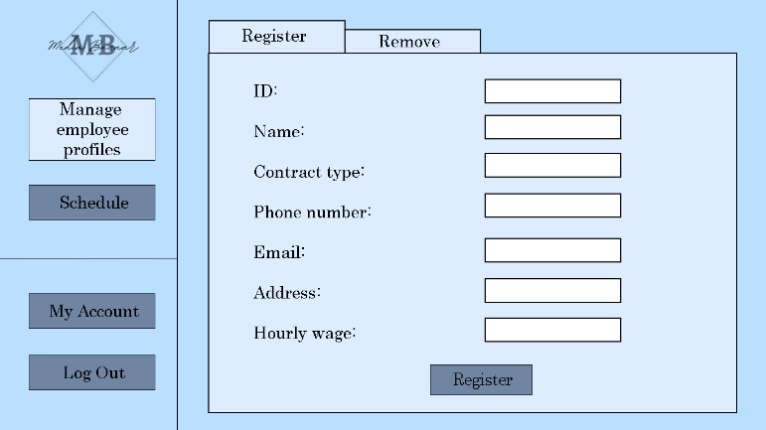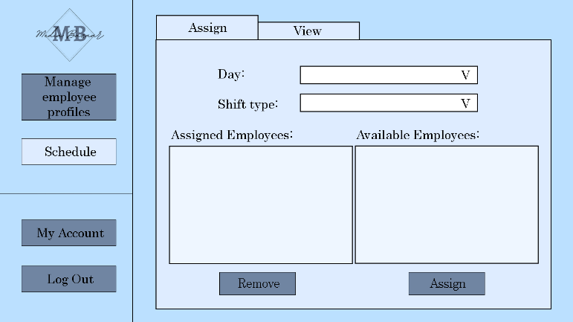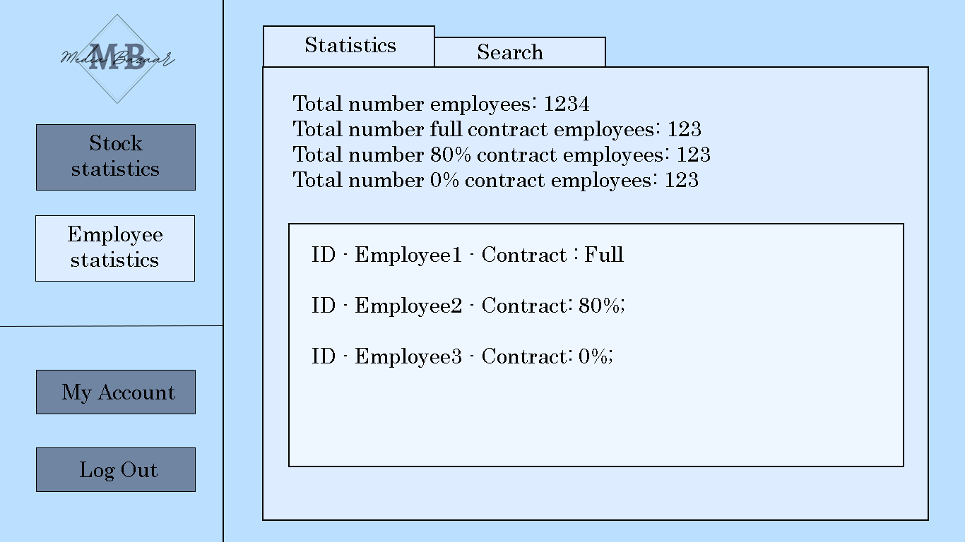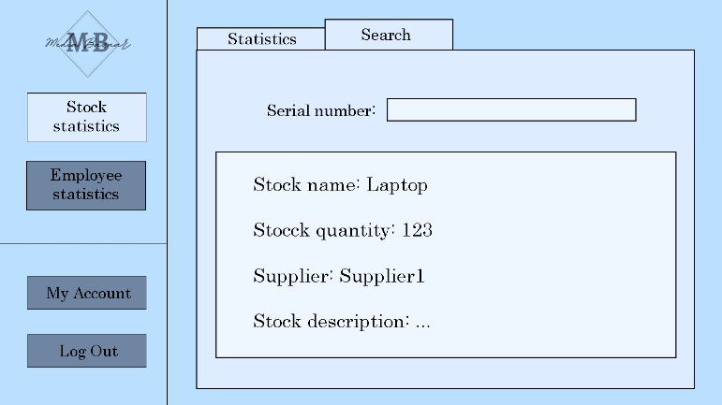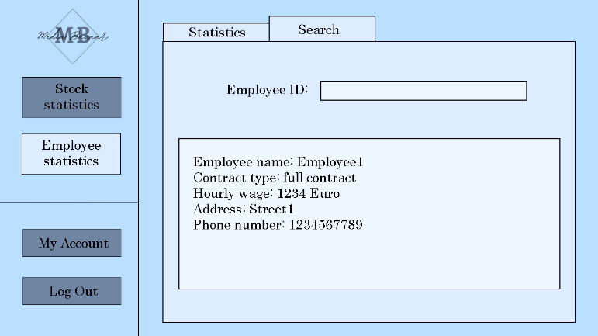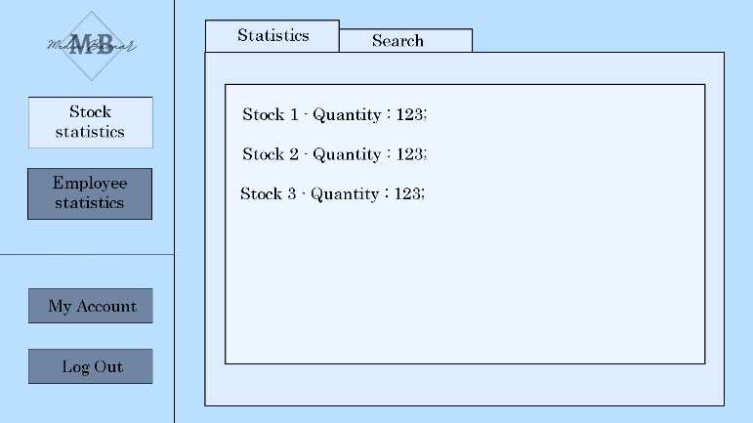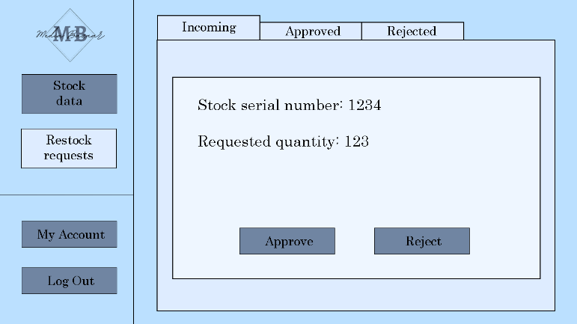

Here’s the shift for the week and the employee assigned to them.

Here is where HR administration can assign employee shifts.

This is how the HR administration removes employee.

This is how the HR administration adds employee.

Here the management can search for an individual employee by their unique id number.

The management can see all the employees statistic.

The Management can search for a specific product here.

The Management can see stock statistic.

Depot worker can see the stock request.

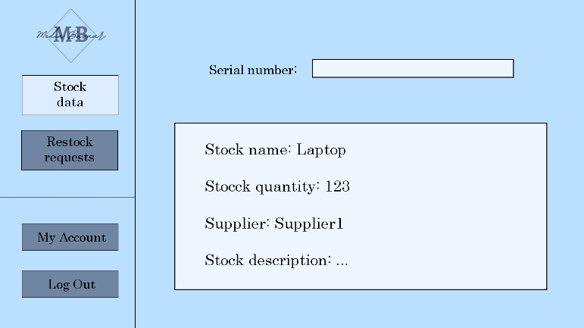

# Website wireframe

Coming soon.